1.Abstact:
Hospital Appointment Management is an important task that requires efficient storage, searching, insertion, and deletion of appointment records. In a hospital, a large number of patients may book appointments with doctors, making it difficult to manage the records using simple data structures. This mini project presents a Hospital Appointment Management System using an AVL Tree, a self-balancing Binary Search Tree.
In this system, each appointment is stored as a node in the AVL Tree using a unique appointment or patient ID as the key. The system supports important operations such as adding a new appointment, searching for an appointment, deleting an appointment, and displaying appointment records. Since an AVL Tree automatically maintains its balance after insertion and deletion using rotations, the height of the tree remains small. This provides efficient searching, insertion, and deletion with a time complexity of O(log n).
The proposed system demonstrates how AVL Trees can be applied to a real-world hospital environment to organize appointment records efficiently. It helps reduce search time, maintain records in an organized manner, and provides a practical application of self-balancing trees in data structure management.
2.Introduction:
Hospitals handle a large number of patient appointments every day. Managing these appointments efficiently is important to reduce waiting time and ensure that patients can meet the correct doctor at the scheduled time. Appointment records may include information such as patient ID, patient name, doctor name, appointment date, and appointment time. As the number of records increases, searching and managing them using simple methods can become time-consuming.
Data structures provide efficient ways to store and manage large amounts of information. One useful data structure for this purpose is the AVL Tree. An AVL Tree is a self-balancing Binary Search Tree in which the difference between the heights of the left and right subtrees of any node is at most one. Whenever an insertion or deletion makes the tree unbalanced, rotations are performed to restore its balance.
In this project, the AVL Tree is used to manage hospital appointment records. Each appointment is stored as a node, with a unique patient or appointment ID used as the key. The system allows users to insert new appointments, search for existing appointments, delete cancelled appointments, and display the records in an organized manner.
The main advantage of using an AVL Tree is that it maintains efficient performance even when a large number of appointments are stored. Searching, insertion, and deletion can be performed in O(log n) time. Therefore, the project demonstrates how a self-balancing tree can be applied to a real-world hospital appointment management system.
3.Literature Review:
1. Niu et al. (2024) – A Review of Optimization Studies for System Appointment Scheduling
Niu et al. presented a comprehensive review of appointment scheduling systems used in healthcare. The study discussed different scheduling structures, objectives, constraints, and optimization techniques. It found that genetic algorithms, simulation optimization, neural networks, and deep learning are commonly used to improve healthcare appointment scheduling. The paper highlights the importance of efficient appointment management for balancing medical resources and patient satisfaction. This study provides a foundation for developing efficient data management techniques for hospital appointments.
2. Han et al. (2024) – A Multi-Appointment Patient Scheduling System with Machine Learning and Optimization
Han et al. proposed a patient scheduling system that combines machine learning with optimization techniques. The research considered factors such as patient no-shows and variations in appointment duration. Machine learning was used to estimate no-show probabilities and appointment durations, while optimization models were used to generate better schedules. The results showed that considering these factors can improve resource utilization and reduce waiting and overtime. This research demonstrates the importance of efficient management of appointment records in healthcare systems.
3. Valenzuela-Núñez et al. (2024) – Smart Medical Appointment Scheduling
Valenzuela-Núñez et al. developed a smart medical appointment scheduling approach using optimization, machine learning, and overbooking strategies. The study focused on the problem of patient no-shows and their effect on healthcare resource utilization. The research showed that intelligent scheduling methods can improve patient flow and make better use of available medical resources. The study supports the need for efficient systems that can store, search, and manage appointment information quickly.
4. Cai et al. (2024) – Managing Appointment-Based Services with Electronic Visits
Cai et al. studied appointment scheduling in healthcare environments that include electronic visits. The research developed optimization methods for jointly scheduling regular appointments and electronic visit time windows. The study proposed efficient algorithms for generating suitable schedules while considering healthcare service requirements. This work shows how modern healthcare appointment systems require efficient scheduling and management of large numbers of appointment records.
5. Zuo et al. (2024) – Outpatient Scheduling Problem in Smart Hospital
Zuo et al. investigated outpatient scheduling in smart hospitals and proposed a graph-based two-agent deep reinforcement learning algorithm. The study focused on increasing demand for medical services and limited healthcare resources. It considered the scheduling of patients, medical staff, and facilities to improve healthcare efficiency. The research demonstrates the growing use of computational techniques for solving complex hospital scheduling problems.
6. Stakeholders’ Experiences with an Electronic Appointment System (2025)
A 2025 study published in BMC Health Services Research examined the experiences and satisfaction of patients, physicians, and administrative staff using an electronic appointment system. The research identified problems related to planning, management, functionality, and system requirements. It concluded that although electronic appointment systems simplify the appointment process, proper planning and management are necessary for effective operation. This study highlights the importance of designing appointment systems that are both efficient and easy to manage.
4.Problem Statement and Objectives:
Problem Statement:
Hospitals manage a large number of patient appointments every day, including new bookings, rescheduled appointments, cancellations, and completed appointments. Managing these records becomes difficult when the number of patients increases, as important appointment details may be difficult to locate quickly. Searching for a particular patient's appointment can take more time when records are not properly organized. Frequent addition and removal of appointments can also make maintaining accurate and up-to-date records challenging. Therefore, an efficient method is required to manage the growing number of hospital appointment records and provide quick access to the required appointment information.
Objectives:
The main objectives of the Hospital Appointment Management Using AVL Trees project are:
1.To develop an efficient hospital appointment management system for storing and organizing patient appointment records.
2.To use an AVL Tree for maintaining appointment records in a self-balancing structure.
3.To implement insertion operations for adding new patient appointments to the system.
4.To implement search operations for quickly finding an appointment using a unique patient or appointment ID.
5.To implement deletion operations for removing cancelled or completed appointments.
6.To maintain AVL Tree balance using LL, RR, LR, and RL rotations whenever required.
7.To improve the efficiency of appointment management by achieving approximately O(log n) time complexity for search, insertion, and deletion operations.
5.Dataset Description:
The dataset used in this project represents hospital appointment records maintained for different patients. Each record contains important information such as Appointment ID, Patient ID, Patient Name, Doctor Name, Appointment Date, Appointment Time, and Department. The Appointment ID is used as a unique identifier for each appointment and helps in storing and retrieving records efficiently. The dataset can contain both existing appointments and newly added appointments, along with records that may be cancelled or deleted. Sample appointment data is created to demonstrate the insertion, searching, deletion, and display operations of the proposed system. The dataset can be expanded with more appointment records to test the performance of the system with different numbers of patients.
6.Proposed Method and Methodology:
Proposed Method:
The proposed system is a Hospital Appointment Management System using an AVL Tree. The system stores each hospital appointment as a node in the AVL Tree. Each node contains details such as Appointment ID, Patient ID, Patient Name, Doctor Name, Appointment Date, Appointment Time, and Department. A unique Appointment ID is used as the key for arranging the records in the tree.
The AVL Tree is a self-balancing Binary Search Tree. After every insertion or deletion, the balance factor of the affected nodes is checked. If the tree becomes unbalanced, suitable rotations such as LL, RR, LR, and RL rotations are performed to restore balance. This helps maintain efficient performance while managing a large number of appointment records.
Methodology:
The methodology of the proposed system consists of the following steps:
1.Data Collection: Hospital appointment records are created with details such as patient information, doctor details, date, time, and department.
2.Node Creation: Each appointment is represented as a node containing the appointment details and pointers to its left and right child nodes.
3.Insertion: New appointments are inserted into the AVL Tree according to their unique Appointment ID. After insertion, the balance factor is checked and rotations are performed if necessary.
4.Searching: When a user enters an Appointment ID, the system searches the AVL Tree by comparing the given ID with the node values and displays the corresponding appointment details if found.
5.Deletion: Cancelled or completed appointments can be removed from the tree. After deletion, the tree is rebalanced whenever required.
6.Display: The appointment records are displayed using tree traversal, such as inorder traversal, which presents the records in ascending order of Appointment ID.
7.Performance Analysis: The efficiency of the system is evaluated based on the time required for insertion, searching, and deletion. The AVL Tree provides O(log n) time complexity for these operations in a balanced tree.
7.Simulation / Implementation Setup:
Program:
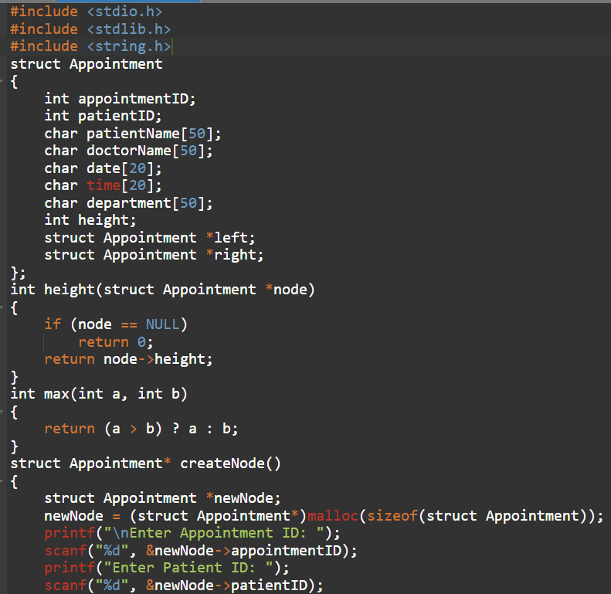
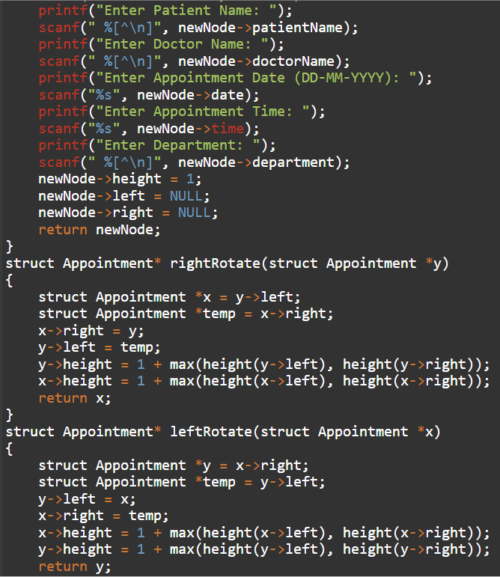
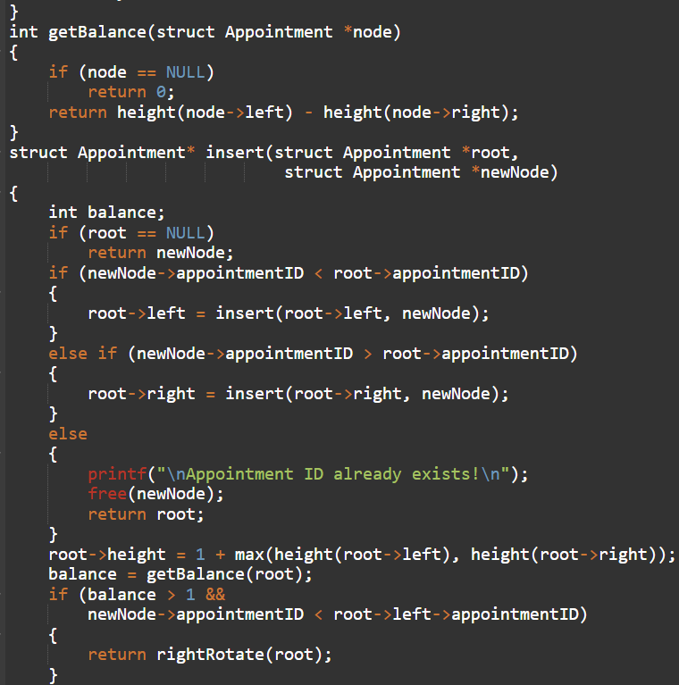
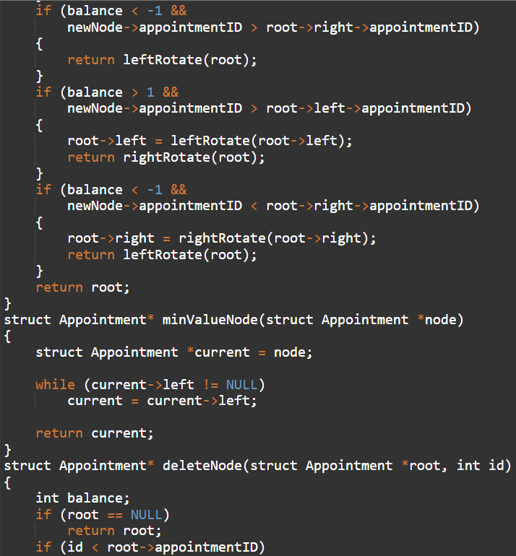
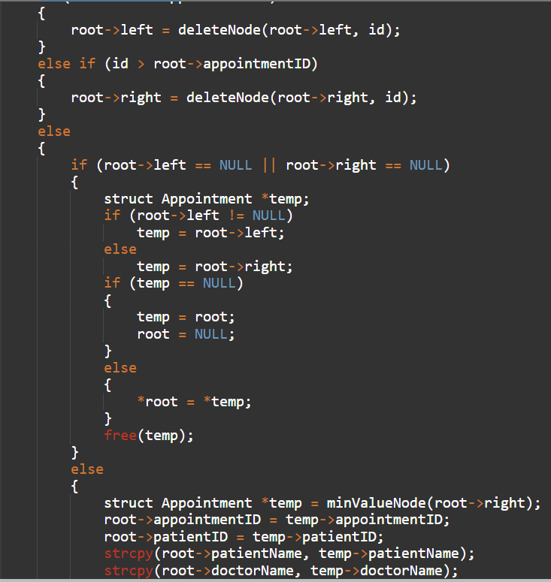
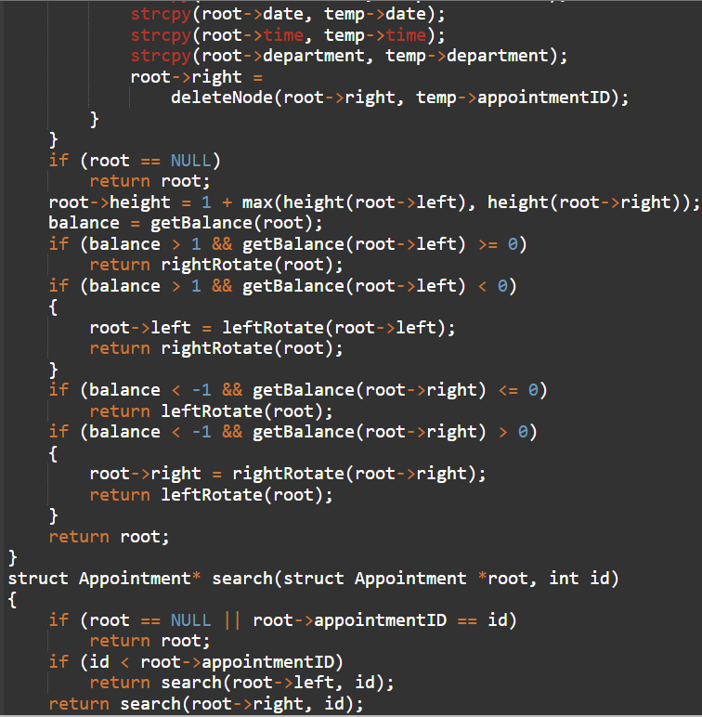
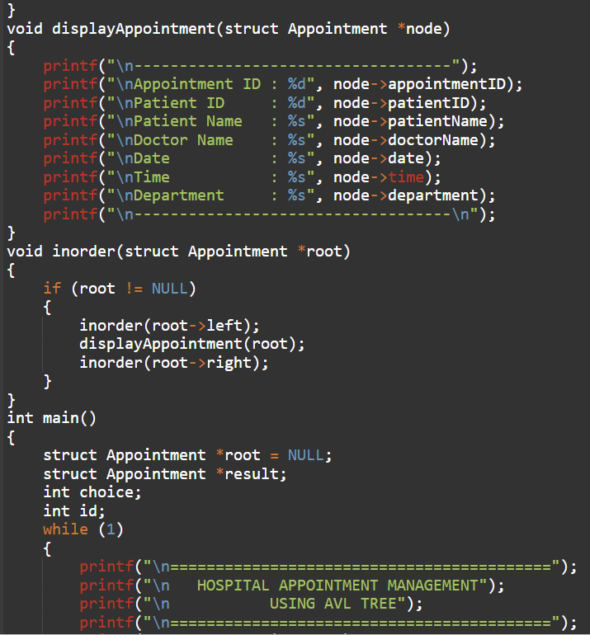
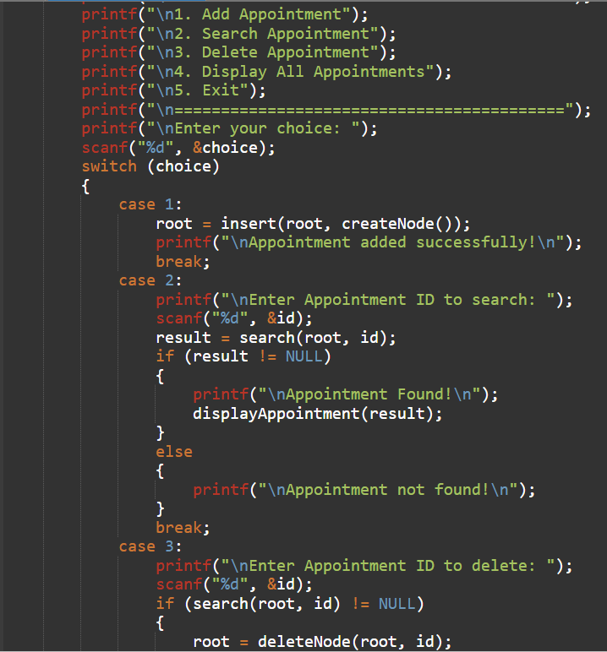
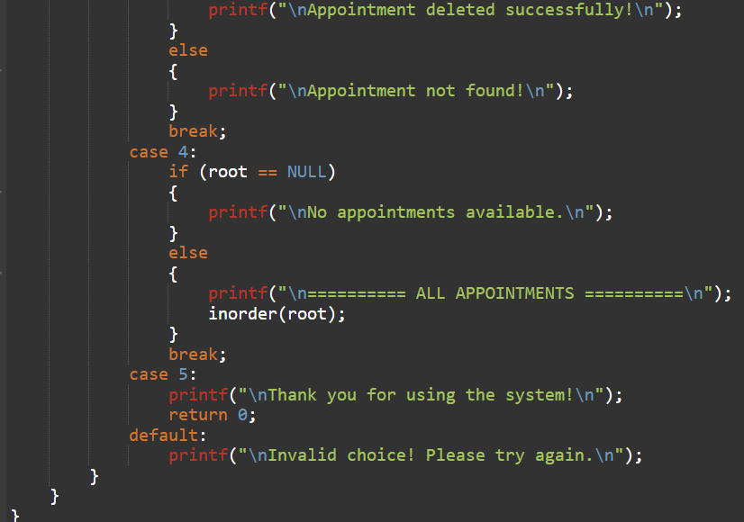
Output:
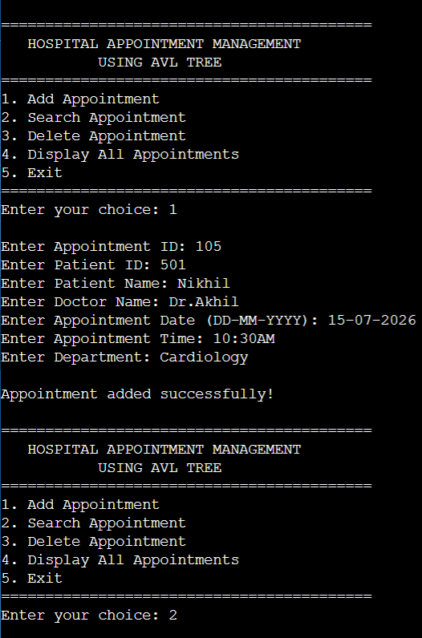
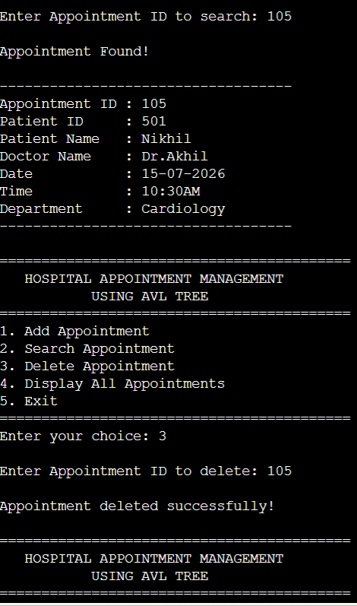
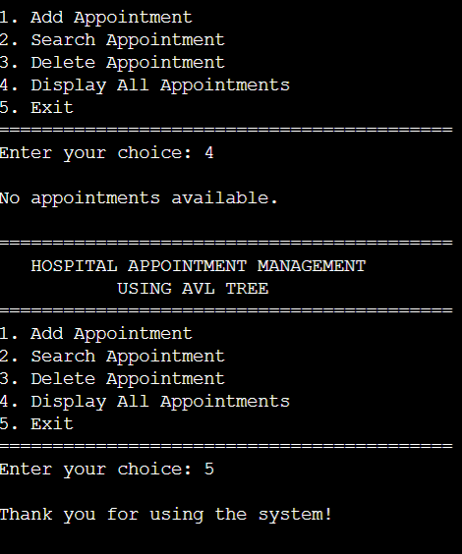
Explanation:
The proposed Hospital Appointment Management System is implemented using the C programming language because it provides efficient handling of dynamic data structures such as trees and supports the use of pointers. The AVL Tree is implemented using dynamically created nodes, where each node stores the appointment details along with pointers to its left and right child nodes. The system is developed and tested using an online C compiler or a C programming environment.
The implementation uses a set of sample hospital appointment records containing details such as Appointment ID, Patient ID, Patient Name, Doctor Name, Appointment Date, Appointment Time, and Department. The Appointment ID is used as the key for arranging the records in the AVL Tree. The main operations implemented are insertion, searching, deletion, and inorder traversal. During insertion and deletion, the balance factor is calculated and appropriate AVL rotations are performed whenever the tree becomes unbalanced.
The system is tested with different numbers of appointment records to verify the correctness of the AVL Tree operations and observe its efficient performance. The simulation demonstrates that the tree remains balanced while appointment records are added or removed, allowing the system to perform search, insertion, and deletion efficiently.
8.Results & Performance Analysis:
The Hospital Appointment Management System was successfully implemented using an AVL Tree. The system was tested with different appointment records to verify the insertion, searching, deletion, and display operations. The appointment records were stored according to their unique Appointment IDs, and the AVL Tree automatically maintained its balance after insertion and deletion.
The insertion operation successfully added new appointment records while maintaining the balance of the tree. The search operation quickly retrieved the required appointment details using the Appointment ID. The deletion operation successfully removed selected appointment records and rebalanced the tree when necessary. The inorder traversal displayed all the stored appointments in ascending order of Appointment ID, making the records easy to view.
The performance of the system was analyzed based on the main AVL Tree operations. Since an AVL Tree maintains a balanced structure, the height of the tree remains O(log n). Therefore, searching, insertion, and deletion operations have an average and worst-case time complexity of O(log n). The space complexity of storing n appointment records is O(n).
Operation | Time Complexity
Insertion | O(log n)
Searching | O(log n)
Deletion | O(log n)
Inorder Traversal | O(n)
Storage | O(n)

The results show that using an AVL Tree provides efficient management of hospital appointment records. The self-balancing property helps maintain consistent performance even when appointments are frequently added or removed. Thus, the implemented system provides an efficient approach for organizing and retrieving hospital appointment information.
9.Conclusion & Future Work:
Conclusion:
The Hospital Appointment Management System using AVL Trees was successfully designed and implemented to manage patient appointment records efficiently. The system supports important operations such as insertion, searching, deletion, and display of appointment records. The AVL Tree maintains a balanced structure through appropriate rotations, which helps provide efficient performance for managing appointment data. The project demonstrates how a fundamental data structure can be applied to a real-world hospital management problem. The results show that AVL Trees can provide fast and organized access to appointment records, with search, insertion, and deletion operations having a time complexity of O(log n).
Future Work:
The system can be further improved by adding more features and making it suitable for real-world hospital use. Future improvements may include:
1.Adding a graphical user interface (GUI) for easier interaction.
2.Connecting the system to a database for permanent storage of appointment records.
3.Adding doctor availability and time-slot management.
4.Providing patient registration and medical history management.
5.Adding appointment reminders and notifications.
6.Supporting multiple hospital departments and doctors.
7.Adding login and authentication features for patients, doctors, and hospital staff.
8.Developing a web or mobile version so that patients can book and manage appointments remotely.
10.References:
1.Niu, L., et al. (2024). A Review of Optimization Studies for System Appointment Scheduling. The Hong Kong Polytechnic University.
2.Han, Y., et al. (2024). A Multi-Appointment Patient Scheduling System with Machine Learning and Optimization. Decision Analytics Journal, 10, 100392.
3.Valenzuela-Núñez, A., et al. (2024). Smart Medical Appointment Scheduling: Optimization, Machine Learning, and Overbooking to Enhance Resource Utilization.
4.Cai, X., et al. (2024). Managing Appointment-Based Services with Electronic Visits. European Journal of Operational Research.
5.Zuo, X., et al. (2024). Outpatient Scheduling Problem in Smart Hospital: A Graph-Based Two-Agent Deep Reinforcement Learning Approach. International Journal of Data Warehousing and Mining.
6.Stakeholders’ Experiences with an Electronic Appointment System: A Qualitative Study. (2025). BMC Health Services Research.
11.GitHub Link:

